**Calculated Column Questions**

1. Calculate the **Total Cost** for each movie/TV show (Making Charges + Marketing Expense + Star Cost Production Charge).
2. Calculate the **Profit Margin (%)** for each movie/TV show ((Profit / Total Cost) * 100).
3. Create a column for **Net Profit** (Profit - (Marketing Expense + Star Cost Production Charge)).
4. Derive the **Profit per Viewer** (Profit / Views (Million)).
5. Compute the **Star Cost Percentage** of the total making charges (Star Cost Production Charge / Making Charges * 100).
6. Calculate the **Total Marketing Spend** for each movie/TV show based on the **Marketing Expense** and **Royalty Percentage**.
7. Add a column to show the **Yearly Viewer Increase** based on % Increase in Viewers.
8. Create a column for **Revenue Generated per Viewer** (Profit / Sales).
9. Determine the **Average IMDb and Rotten Tomatoes Rating**.
10. Create a column for **OTT Profit Share** (Royalty Percentage * Profit / 100).
11. Calculate the **Making Efficiency (%)** (Profit / Making Charges * 100).
12. Create a column to determine the **Primary Genre Group** (e.g., "Action", "Drama") based on Genre.
13. Add a column for **Age Group Popularity** by splitting the Age Group Wise Favorite column.
14. Determine the **Seasons-to-Year Ratio** (Number of Seasons / (2024 - Release Year)).
15. Calculate the **Adjusted Profit** by considering inflation for older releases (Profit + (Profit * (2024 - Release Year) * 0.02)).

**KPI (Key Performance Indicator) Questions**

**1.Total Profit** for all movies/shows combined : 3302059

**2.Average IMDb Rating** of all movies/shows : 8.497383333

3.Total **Sales in Numbers** across all platforms : 4.80464E+11

**4.Total Marketing Expense** across all movies/shows : 418319

5.Top 5 movies/shows by **Profit Margin**.

|  |  |
| --- | --- |
| **Row Labels** | **Sum of Profit Margin (%)** |
| Cold. | 883.3580265 |
| Country add. | 963.2653061 |
| Interesting. | 779.906426 |
| Maintain bit analysis. | 769.7674419 |
| War. | 866.8378223 |
| **Grand Total** | **4263.135023** |

6.Total **Views (Million)** for each genre.

|  |  |
| --- | --- |
| **Row Labels** | **Sum of Views (Million)** |
| Action | 78213 |
| Crime | 81307 |
| Drama | 80102 |
| Fantasy | 78547 |
| Sci-Fi | 82157 |
| Thriller | 79147 |
| **Grand Total** | **479473** |

7.Average **Making Charges** for movies in the same country.

|  |  |
| --- | --- |
| **Row Labels** | **Average of Making Charges ($M)** |
| India | 89.08837525 |
| Spain | 89.90580899 |
| UK | 89.94149294 |
| USA | 89.64109318 |
| **Grand Total** | **89.64725** |

**8.Highest Profit Margin** by language

|  |  |
| --- | --- |
| **Row Labels** | **Max of Profit Margin (%)** |
| English | 670.9090909 |
| Hindi | 587.1794872 |
| Spanish | 963.2653061 |
| **Grand Total** | **963.2653061** |

9.Top 3 **Star Cost Production Charges** for each country.

|  |  |
| --- | --- |
| **Row Labels** | **Sum of Star Cost Production Charge ($M)** |
| Spain | 464430 |
| UK | 455058 |
| USA | 452515 |
| **Grand Total** | **1372003** |

10.Average **Royalty Percentage** for OTT platforms.

|  |  |
| --- | --- |
| **Row Labels** | **Average of Royalty Percentage** |
| Amazon Prime | 50.9098063 |
| Disney+ | 48.81902548 |
| HBO Max | 50.62095154 |
| Hulu | 50.54947376 |
| Netflix | 50.20307605 |
| **Grand Total** | **50.21732283** |

**11.Total Revenue** generated for shows with IMDb Ratings > 9 : **1050897**

12.The percentage of movies in the **25-54 Age Group Favorite** category.

|  |  |
| --- | --- |
| **Age Group** | **Count of TV Show/Movie Name** |
| 18-34 | 1283 |
| 18-45 | 1281 |
| 25-54 | 1245 |
| **Grand Total** | **3809** |

1. Total profit for movies released after 2010.

**Sum of Profit ($M) -** 278574

1. Average views for each **OTT Channel**.

|  |  |
| --- | --- |
| **Row Labels** | **Average of Views (Million)** |
| Amazon Prime | 41.22337662 |
| Disney+ | 38.80133333 |
| HBO Max | 39.8488529 |
| Hulu | 39.14923469 |
| Netflix | 39.21596859 |
| **Grand Total** | **39.64951431** |

1. Total marketing expense on **social media platforms**.

|  |  |
| --- | --- |
| **Row Labels** | **Sum of Marketing Expense ($M)** |
| Facebook, Instagram | 34348 |
| Instagram, Twitter | 32742 |
| Twitter, Facebook | 33842 |
| YouTube, Instagram | 32268 |
| **Grand Total** | **133200** |

Total views per **Star Cast** : - **151025**

Average profit margin for movies with **Rotten Tomatoes Rating** > 90% : - **114.7231262**

Average profit generated per **season** :

|  |  |
| --- | --- |
| **Number of Seasons** | **Average of Profit ($M)** |
| 1 | 278.6306892 |
| 2 | 275.1409922 |
| 3 | 271.1180371 |
| 4 | 277.1296791 |
| 5 | 277.4041451 |
| **Grand Total** | **275.8983985** |

Average making charges per **language** :

|  |  |
| --- | --- |
| **Language** | **Average of Making Charges ($M)** |
| English | 89.32802548 |
| Hindi | 90.36711712 |
| Spanish | 89.42751843 |
| **Grand Total** | 269.1227 |

Total marketing expenses for movies using **Instagram** as a platform : **99358 (includes Facebook ,Twitter, YouTube)**

Average sales for thrillers rated above 9 : 40328028.41

Average IMDb rating for movies with more than 3 seasons : 14419.5

Total adjusted profit for movies released before 2000 : 1024719

Top 5 OTT channels by total profit :

|  |  |
| --- | --- |
| **OTT Channel** | **Sum of Profit ($M)** |
| Amazon Prime | 214456 |
| Disney+ | 203490 |
| HBO Max | 208784 |
| Hulu | 214987 |
| Netflix | 209180 |
| **Grand Total** | **1050897** |

Total viewers per **Age Group** :

|  |  |
| --- | --- |
| **Age Group** | **Sum of Views (Million)** |
| 18-34 | 50252 |
| 18-45 | 51135 |
| 25-54 | 49638 |
| **Grand Total** | **151025** |

**Visual-Based Questions**

**Bar Charts**

1. Show the **profit** by **OTT channel** with slicers for **country** and **language**.

|  |  |
| --- | --- |
| **OTT Platform** | **Count of Profit ($M)** |
| Amazon Prime | 62 |
| Disney+ | 70 |
| HBO Max | 59 |
| Hulu | 69 |
| Netflix | 66 |
| **Grand Total** | **326** |

1. Compare the **views (millions)** for movies by **genre** with slicers for **release year** and **age group**.

|  |  |
| --- | --- |
| **Genre** | **Count of Views (Million)** |
| Action | 342 |
| Crime | 372 |
| Drama | 342 |
| Fantasy | 349 |
| Sci-Fi | 356 |
| Thriller | 344 |
| **Grand Total** | **2105** |

1. Display the total **profit margin** for each **social media marketing platform** with slicers for **release year** and **OTT channel**.

|  |  |
| --- | --- |
| **OTT Platform** | **Sum of Profit Margin (%)** |
| Facebook, Instagram | 62284.69314 |
| Instagram, Twitter | 58618.32845 |
| YouTube, Instagram | 57436.23689 |
| **Grand Total** | **178339.2585** |

|  |  |
| --- | --- |
| **TV Show/Movie Name** | **Sum of Profit ($M)** |
| For. | 1435 |
| Hope. | 1495 |
| Piece. | 1560 |
| Reality. | 2031 |
| War. | 1728 |
| **Grand Total** | **8249** |

1. Identify the top 5 movies/shows with the highest **profit margins**, with slicers for **language** and **country**.

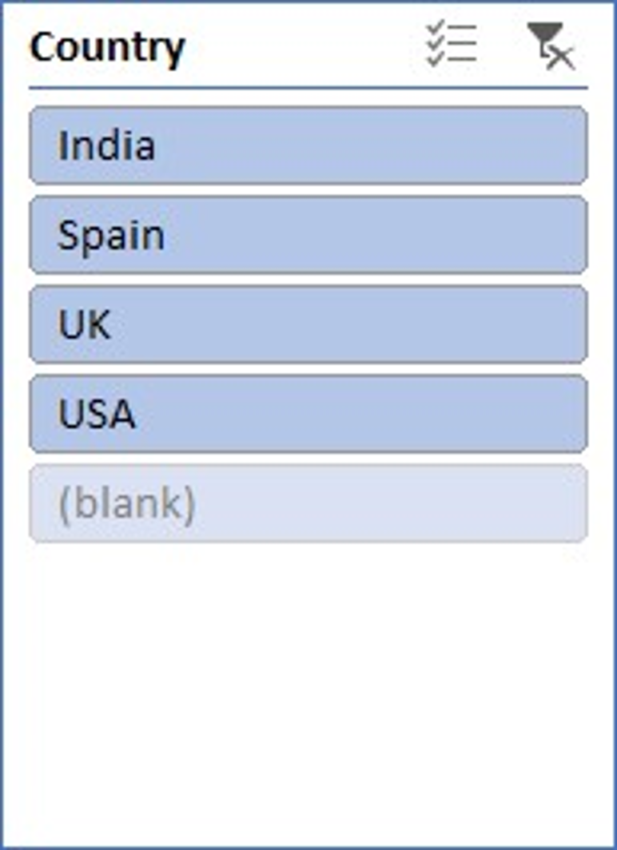

1. Show the **number of sales** by **star cast**, using slicers for **release year** and **genre**.

|  |  |
| --- | --- |
| **Star Cast Name** | **Sum of Sales (Numbers)** |
| Cheryl Fowler, Diane Randall, Sarah Collins | 29995042 |
| Erik Brown, Sharon Donovan, William Thompson | 46330381 |
| Jacob Jones, Bryan Morales, Lauren Stephens | 23117886 |
| Kimberly Holt, Leonard Gross, Richard Kramer | 43283657 |
| Marcus Johnson, Patricia Pugh, Jesse Pittman | 51792980 |
| Melanie Campbell, Benjamin Cherry, John Flores | 51226997 |
| Philip Thomas, William Green, Tanner Rodriguez | 30508071 |
| **Grand Total** | **276255014** |
|  |  |

1. Compare the **total making charges** for movies in different **genres**, with slicers for **country** and **OTT channel**.

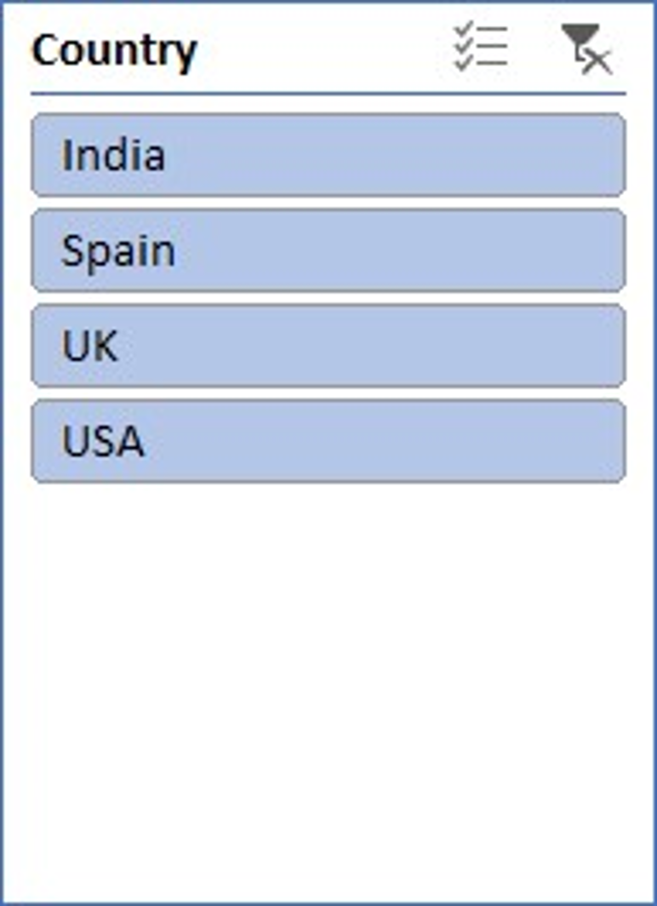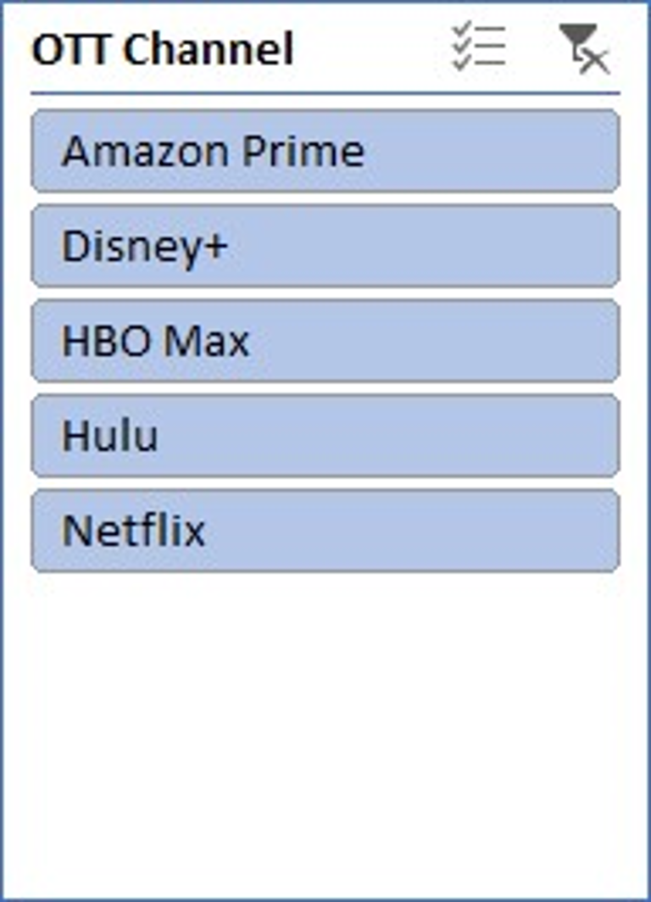

|  |  |
| --- | --- |
| **Genre** | **Sum of Making Charges ($M)** |
| Action | 56635 |
| Crime | 58349 |
| Drama | 54226 |
| Fantasy | 55416 |
| Sci-Fi | 59231 |
| Thriller | 57899 |
| **Grand Total** | **341756** |

|  |  |
| --- | --- |
| **Producers Name** | **Sum of Marketing Expense ($M)** |
| Amanda Hernandez | 12 |
| Amanda Jackson | 40 |
| Amber Shields | 54 |
| Andrew Perry IV | 29 |
| Ashley Jones | 32 |
| Brandy Padilla | 25 |
| Brian Thomas | 39 |
| Caitlyn Park | 16 |
| Charles Ponce | 15 |
| Chelsea Davila | 43 |
| Deborah Duncan | 16 |
| Donald Lewis | 21 |
| Elizabeth Pitts | 56 |
| Gary Petersen | 34 |
| Jason Ball | 27 |
| Jason Todd | 22 |
| Jennifer Smith | 55 |
| Jeremy Contreras | 14 |
| Joe Martinez | 18 |
| John Booth | 45 |
| Jorge Baldwin | 37 |
| Kaitlyn Brown | 38 |
| Keith Hicks | 21 |
| Kelly Meyer | 54 |
| Kevin Miller | 26 |
| Kevin Owens | 52 |
| Maria Mcconnell | 51 |
| Marisa Scott DDS | 53 |
| Michelle Welch | 59 |
| Steven Crawford | 54 |
| Susan Cervantes | 16 |
| Tanya Torres | 12 |
| Valerie Woods | 23 |
| **Grand Total** | **1109** |

1. Display the total **marketing expense** by **producer**, using slicers for **release year** and **language**.

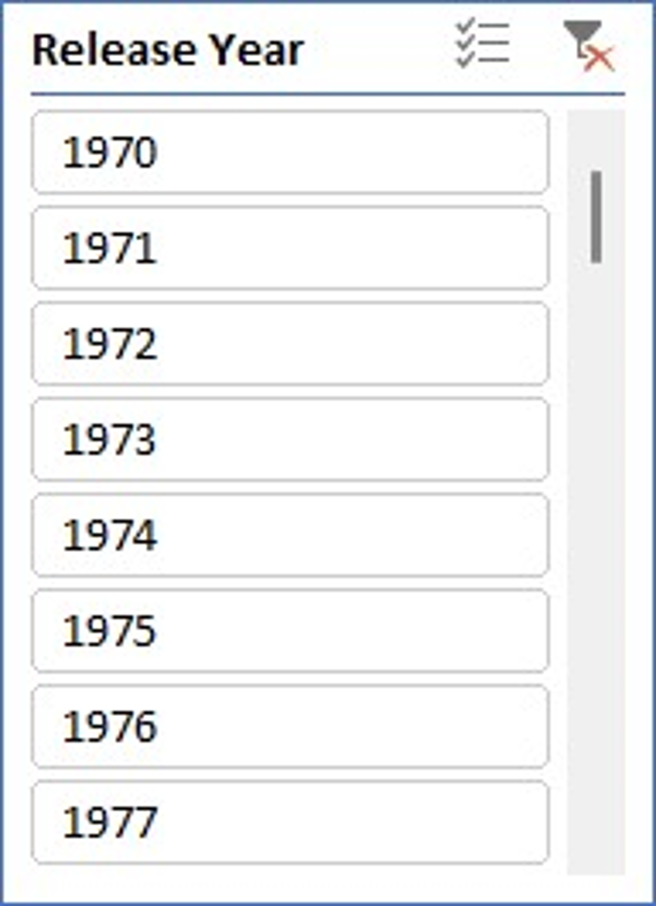

1. Show the **IMDb rating** distribution by **language**, with slicers for **genre** and **OTT channel**.

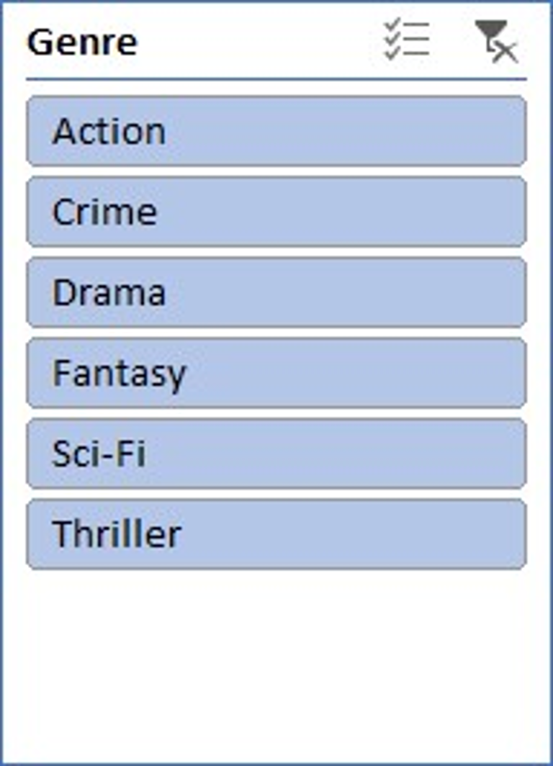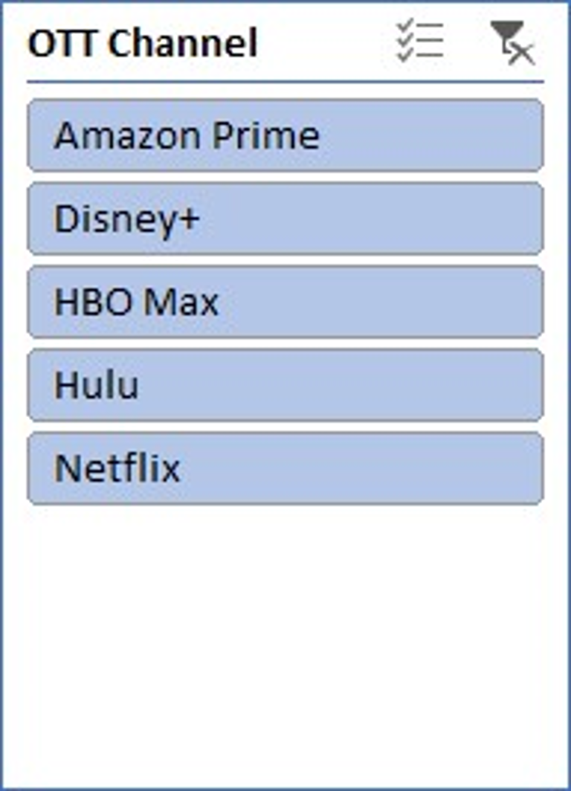

|  |  |
| --- | --- |
| **Language** | **Count of IMDb Rating** |
| English | 1256 |
| Hindi | 1332 |
| Spanish | 1221 |
| **Grand Total** | **3809** |

1. Display the **profit per viewer** by **age group**, using slicers for **country** and **language**.



|  |  |
| --- | --- |
| **Age Group** | **Sum of Profit per Viewer** |
| 18-34 | 11798.42596 |
| 18-45 | 11503.94331 |
| 25-54 | 11218.66228 |
| **Grand Total** | **34521.03155** |

1. Compare the **number of seasons** for movies/shows across different **genres**, with slicers for **OTT channel** and **release year**.

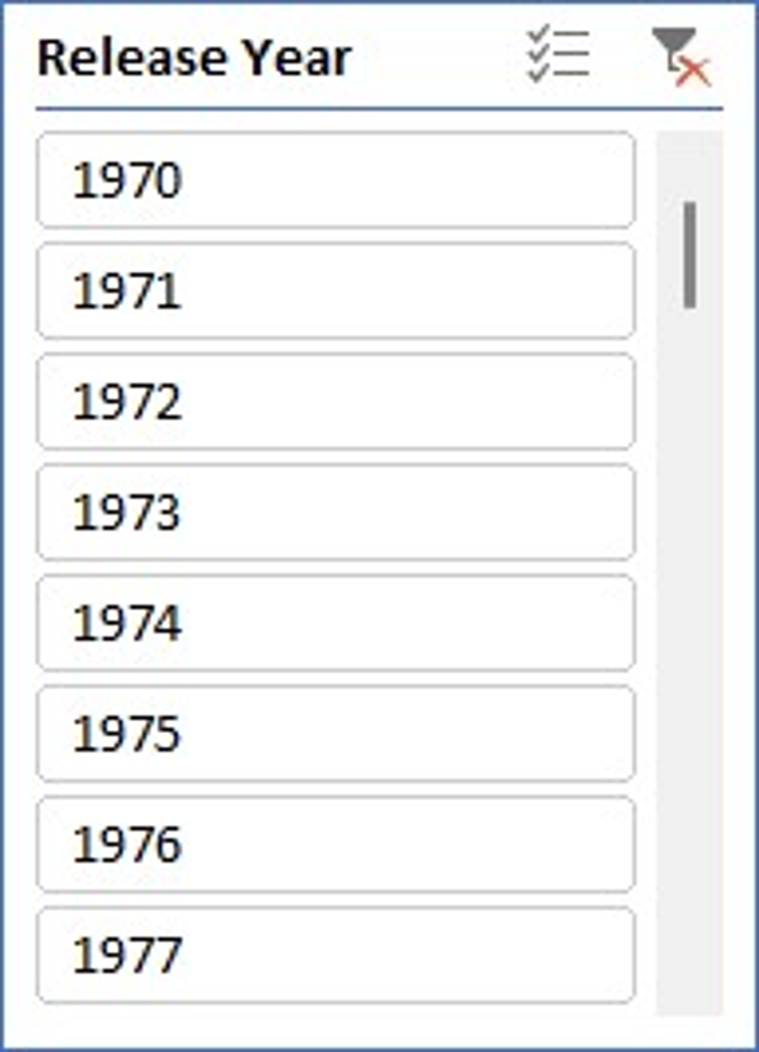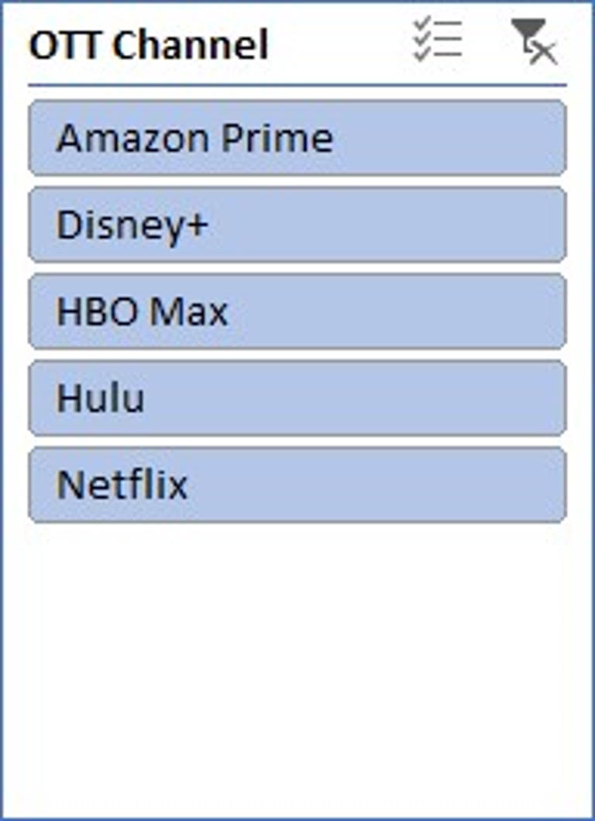

|  |  |
| --- | --- |
| **Genre** | **Count of Number of Seasons** |
| Action | 4 |
| Crime | 6 |
| Drama | 4 |
| Fantasy | 7 |
| Sci-Fi | 5 |
| Thriller | 7 |
| **Grand Total** | **33** |

**Line Charts**

1. Show the **trend of total profit** over the years, with slicers for **country** and **OTT channel**.

|  |  |
| --- | --- |
| **Release Year** | **Count of Profit ($M)** |
| 1970 | 201 |
| 1971 | 228 |
| 1972 | 213 |
| 1973 | 198 |
| 1974 | 222 |
| 1975 | 201 |
| 1976 | 204 |
| 1977 | 222 |
| 1978 | 228 |
| 1979 | 212 |
| 1980 | 210 |
| 1981 | 217 |
| 1982 | 239 |
| 1983 | 232 |
| 1984 | 197 |
| 1985 | 236 |
| 1986 | 215 |
| 1987 | 251 |
| 1988 | 224 |
| 1989 | 218 |
| 1990 | 235 |
| 1991 | 211 |
| 1992 | 234 |
| 1993 | 223 |
| 1994 | 211 |
| 1995 | 215 |
| 1996 | 207 |
| 1997 | 225 |
| 1998 | 232 |
| 1999 | 222 |
| 2000 | 207 |
| 2001 | 229 |
| 2002 | 215 |
| 2003 | 221 |
| 2004 | 223 |
| 2005 | 185 |
| 2006 | 190 |
| 2007 | 214 |
| 2008 | 232 |
| 2009 | 197 |
| 2010 | 180 |
| 2011 | 221 |
| 2012 | 237 |
| 2013 | 226 |
| 2014 | 212 |
| 2015 | 208 |
| 2016 | 260 |
| 2017 | 202 |
| 2018 | 227 |
| 2019 | 250 |
| 2020 | 230 |
| 2021 | 249 |
| 2022 | 231 |
| 2023 | 244 |
| 2024 | 127 |
| **Grand Total** | **12000** |



1. Display the **views (millions)** trend by **release year**, with slicers for **language** and **genre**.

|  |  |
| --- | --- |
| **Release Year** | **Count of Views (Million)** |
| 1970 | 201 |
| 1971 | 228 |
| 1972 | 213 |
| 1973 | 198 |
| 1974 | 222 |
| 1975 | 201 |
| 1976 | 204 |
| 1977 | 222 |
| 1978 | 228 |
| 1979 | 212 |
| 1980 | 210 |
| 1981 | 217 |
| 1982 | 239 |
| 1983 | 232 |
| 1984 | 197 |
| 1985 | 236 |
| 1986 | 215 |
| 1987 | 251 |
| 1988 | 224 |
| 1989 | 218 |
| 1990 | 235 |
| 1991 | 211 |
| 1992 | 234 |
| 1993 | 223 |
| 1994 | 211 |
| 1995 | 215 |
| 1996 | 207 |
| 1997 | 225 |
| 1998 | 232 |
| 1999 | 222 |
| 2000 | 207 |
| 2001 | 229 |
| 2002 | 215 |
| 2003 | 221 |
| 2004 | 223 |
| 2005 | 185 |
| 2006 | 190 |
| 2007 | 214 |
| 2008 | 232 |
| 2009 | 197 |
| 2010 | 180 |
| 2011 | 221 |
| 2012 | 237 |
| 2013 | 226 |
| 2014 | 212 |
| 2015 | 208 |
| 2016 | 260 |
| 2017 | 202 |
| 2018 | 227 |
| 2019 | 250 |
| 2020 | 230 |
| 2021 | 249 |
| 2022 | 231 |
| 2023 | 244 |
| 2024 | 127 |
| **Grand Total** | **12000** |

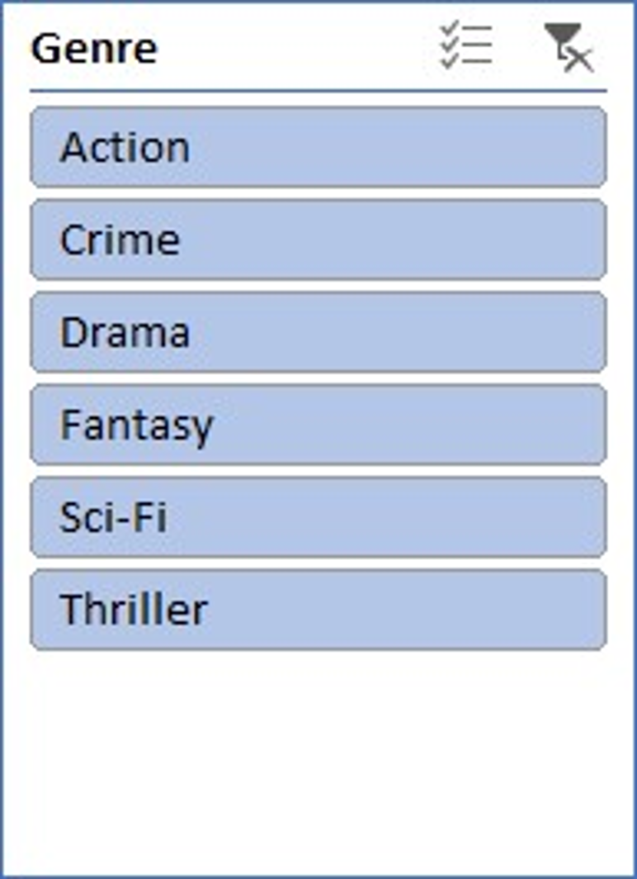s

1. Compare the **IMDb rating** trend over time for movies/shows with slicers for **age group** and **OTT channel**.

|  |  |
| --- | --- |
|  |  |
| **Release Year** | **Count of IMDb Rating** |
| 1970 | 201 |
| 1971 | 228 |
| 1972 | 213 |
| 1973 | 198 |
| 1974 | 222 |
| 1975 | 201 |
| 1976 | 204 |
| 1977 | 222 |
| 1978 | 228 |
| 1979 | 212 |
| 1980 | 210 |
| 1981 | 217 |
| 1982 | 239 |
| 1983 | 232 |
| 1984 | 197 |
| 1985 | 236 |
| 1986 | 215 |
| 1987 | 251 |
| 1988 | 224 |
| 1989 | 218 |
| 1990 | 235 |
| 1991 | 211 |
| 1992 | 234 |
| 1993 | 223 |
| 1994 | 211 |
| 1995 | 215 |
| 1996 | 207 |
| 1997 | 225 |
| 1998 | 232 |
| 1999 | 222 |
| 2000 | 207 |
| 2001 | 229 |
| 2002 | 215 |
| 2003 | 221 |
| 2004 | 223 |
| 2005 | 185 |
| 2006 | 190 |
| 2007 | 214 |
| 2008 | 232 |
| 2009 | 197 |
| 2010 | 180 |
| 2011 | 221 |
| 2012 | 237 |
| 2013 | 226 |
| 2014 | 212 |
| 2015 | 208 |
| 2016 | 260 |
| 2017 | 202 |
| 2018 | 227 |
| 2019 | 250 |
| 2020 | 230 |
| 2021 | 249 |
| 2022 | 231 |
| 2023 | 244 |
| 2024 | 127 |
| **Grand Total** | **12000** |
|  |  |

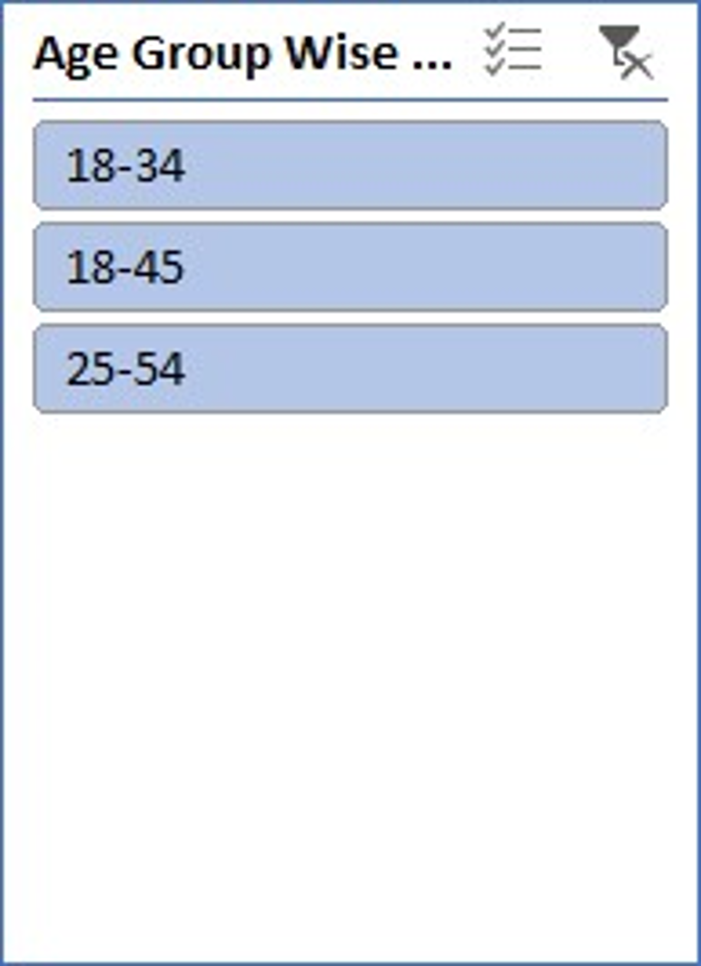

1. Show the **yearly increase in viewers** for movies/shows by **genre**, with slicers for **country** and **language**.

|  |  |
| --- | --- |
|  |  |
| **Genre** | **Count of Yearly Viewer Increase** |
| Action | 1974 |
| Crime | 2027 |
| Drama | 1990 |
| Fantasy | 1980 |
| Sci-Fi | 2066 |
| Thriller | 1963 |
| **Grand Total** | **12000** |

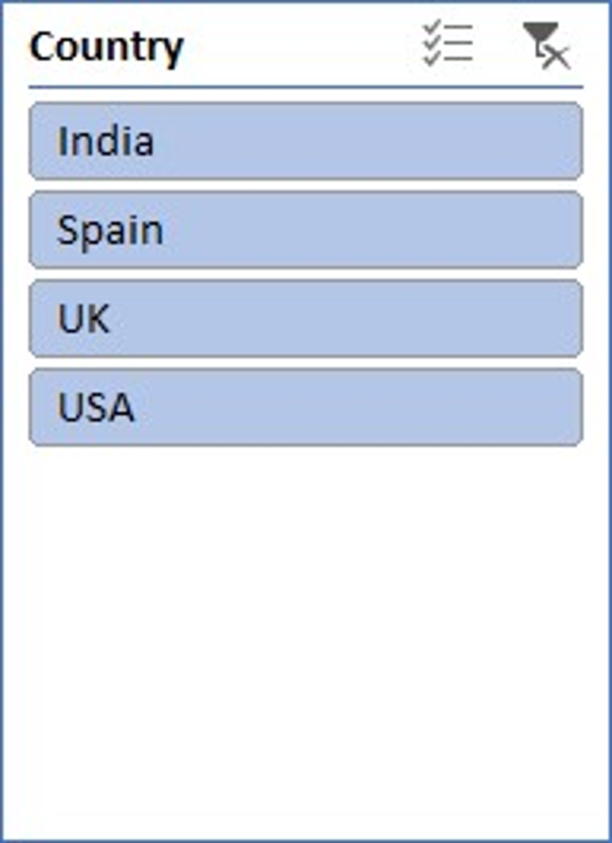

1. Display the **marketing expenses** trend over time for movies/shows with slicers for **social media platform** and **genre**.

|  |  |
| --- | --- |
|  |  |
| **Release Year** | **Count of Marketing Expense ($M)** |
| 1970 | 201 |
| 1971 | 228 |
| 1972 | 213 |
| 1973 | 198 |
| 1974 | 222 |
| 1975 | 201 |
| 1976 | 204 |
| 1977 | 222 |
| 1978 | 228 |
| 1979 | 212 |
| 1980 | 210 |
| 1981 | 217 |
| 1982 | 239 |
| 1983 | 232 |
| 1984 | 197 |
| 1985 | 236 |
| 1986 | 215 |
| 1987 | 251 |
| 1988 | 224 |
| 1989 | 218 |
| 1990 | 235 |
| 1991 | 211 |
| 1992 | 234 |
| 1993 | 223 |
| 1994 | 211 |
| 1995 | 215 |
| 1996 | 207 |
| 1997 | 225 |
| 1998 | 232 |
| 1999 | 222 |
| 2000 | 207 |
| 2001 | 229 |
| 2002 | 215 |
| 2003 | 221 |
| 2004 | 223 |
| 2005 | 185 |
| 2006 | 190 |
| 2007 | 214 |
| 2008 | 232 |
| 2009 | 197 |
| 2010 | 180 |
| 2011 | 221 |
| 2012 | 237 |
| 2013 | 226 |
| 2014 | 212 |
| 2015 | 208 |
| 2016 | 260 |
| 2017 | 202 |
| 2018 | 227 |
| 2019 | 250 |
| 2020 | 230 |
| 2021 | 249 |
| 2022 | 231 |
| 2023 | 244 |
| 2024 | 127 |
| **Grand Total** | **12000** |
|  |  |
|  |  |

1. 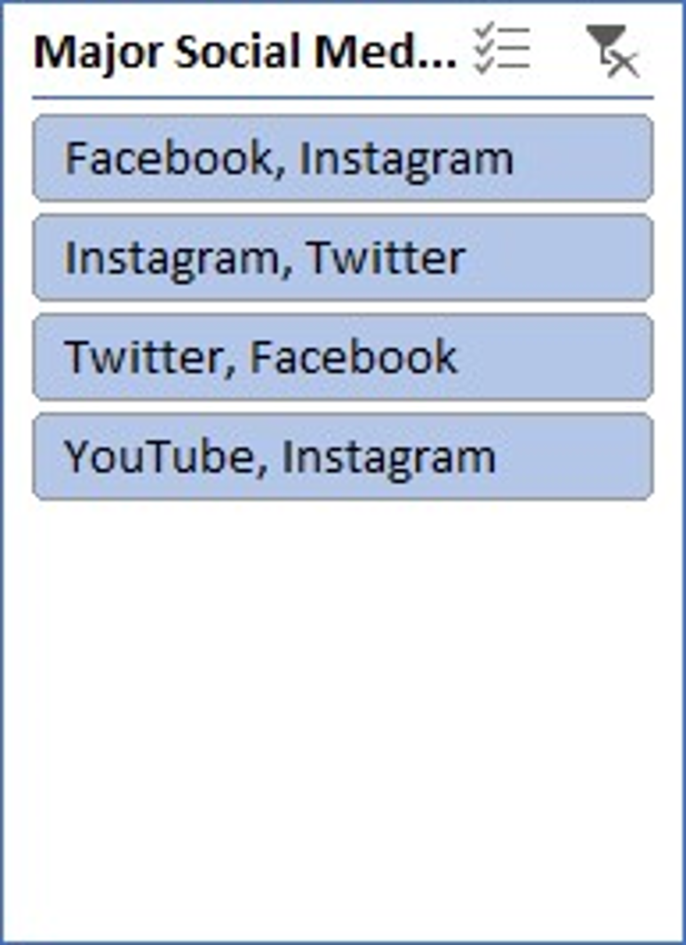
2. Show the **profit margin** trend by **release year**, with slicers for **language** and **OTT channel**.

|  |  |
| --- | --- |
|  |  |
| **Release Year** | **Count of Profit Margin (%)** |
| 1970 | 201 |
| 1971 | 228 |
| 1972 | 213 |
| 1973 | 198 |
| 1974 | 222 |
| 1975 | 201 |
| 1976 | 204 |
| 1977 | 222 |
| 1978 | 228 |
| 1979 | 212 |
| 1980 | 210 |
| 1981 | 217 |
| 1982 | 239 |
| 1983 | 232 |
| 1984 | 197 |
| 1985 | 236 |
| 1986 | 215 |
| 1987 | 251 |
| 1988 | 224 |
| 1989 | 218 |
| 1990 | 235 |
| 1991 | 211 |
| 1992 | 234 |
| 1993 | 223 |
| 1994 | 211 |
| 1995 | 215 |
| 1996 | 207 |
| 1997 | 225 |
| 1998 | 232 |
| 1999 | 222 |
| 2000 | 207 |
| 2001 | 229 |
| 2002 | 215 |
| 2003 | 221 |
| 2004 | 223 |
| 2005 | 185 |
| 2006 | 190 |
| 2007 | 214 |
| 2008 | 232 |
| 2009 | 197 |
| 2010 | 180 |
| 2011 | 221 |
| 2012 | 237 |
| 2013 | 226 |
| 2014 | 212 |
| 2015 | 208 |
| 2016 | 260 |
| 2017 | 202 |
| 2018 | 227 |
| 2019 | 250 |
| 2020 | 230 |
| 2021 | 249 |
| 2022 | 231 |
| 2023 | 244 |
| 2024 | 127 |
| **Grand Total** | **12000** |
|  |  |
|  |  |



1. Compare the **sales (numbers)** trend over time for movies/shows using slicers for **country** and **age group**.

|  |  |
| --- | --- |
|  |  |
| **Release Year** | **Count of Sales (Numbers)** |
| 1970 | 201 |
| 1971 | 228 |
| 1972 | 213 |
| 1973 | 198 |
| 1974 | 222 |
| 1975 | 201 |
| 1976 | 204 |
| 1977 | 222 |
| 1978 | 228 |
| 1979 | 212 |
| 1980 | 210 |
| 1981 | 217 |
| 1982 | 239 |
| 1983 | 232 |
| 1984 | 197 |
| 1985 | 236 |
| 1986 | 215 |
| 1987 | 251 |
| 1988 | 224 |
| 1989 | 218 |
| 1990 | 235 |
| 1991 | 211 |
| 1992 | 234 |
| 1993 | 223 |
| 1994 | 211 |
| 1995 | 215 |
| 1996 | 207 |
| 1997 | 225 |
| 1998 | 232 |
| 1999 | 222 |
| 2000 | 207 |
| 2001 | 229 |
| 2002 | 215 |
| 2003 | 221 |
| 2004 | 223 |
| 2005 | 185 |
| 2006 | 190 |
| 2007 | 214 |
| 2008 | 232 |
| 2009 | 197 |
| 2010 | 180 |
| 2011 | 221 |
| 2012 | 237 |
| 2013 | 226 |
| 2014 | 212 |
| 2015 | 208 |
| 2016 | 260 |
| 2017 | 202 |
| 2018 | 227 |
| 2019 | 250 |
| 2020 | 230 |
| 2021 | 249 |
| 2022 | 231 |
| 2023 | 244 |
| 2024 | 127 |
| **Grand Total** | **12000** |



1. Display the **total making charges** trend for movies/shows by **release year**, with slicers for **OTT channel** and **producer**.

|  |  |
| --- | --- |
|  |  |
| **Release Year** | **Count of Making Charges ($M)** |
| 1970 | 201 |
| 1971 | 228 |
| 1972 | 213 |
| 1973 | 198 |
| 1974 | 222 |
| 1975 | 201 |
| 1976 | 204 |
| 1977 | 222 |
| 1978 | 228 |
| 1979 | 212 |
| 1980 | 210 |
| 1981 | 217 |
| 1982 | 239 |
| 1983 | 232 |
| 1984 | 197 |
| 1985 | 236 |
| 1986 | 215 |
| 1987 | 251 |
| 1988 | 224 |
| 1989 | 218 |
| 1990 | 235 |
| 1991 | 211 |
| 1992 | 234 |
| 1993 | 223 |
| 1994 | 211 |
| 1995 | 215 |
| 1996 | 207 |
| 1997 | 225 |
| 1998 | 232 |
| 1999 | 222 |
| 2000 | 207 |
| 2001 | 229 |
| 2002 | 215 |
| 2003 | 221 |
| 2004 | 223 |
| 2005 | 185 |
| 2006 | 190 |
| 2007 | 214 |
| 2008 | 232 |
| 2009 | 197 |
| 2010 | 180 |
| 2011 | 221 |
| 2012 | 237 |
| 2013 | 226 |
| 2014 | 212 |
| 2015 | 208 |
| 2016 | 260 |
| 2017 | 202 |
| 2018 | 227 |
| 2019 | 250 |
| 2020 | 230 |
| 2021 | 249 |
| 2022 | 231 |
| 2023 | 244 |
| 2024 | 127 |
| **Grand Total** | **12000** |
|  |  |
|  |  |

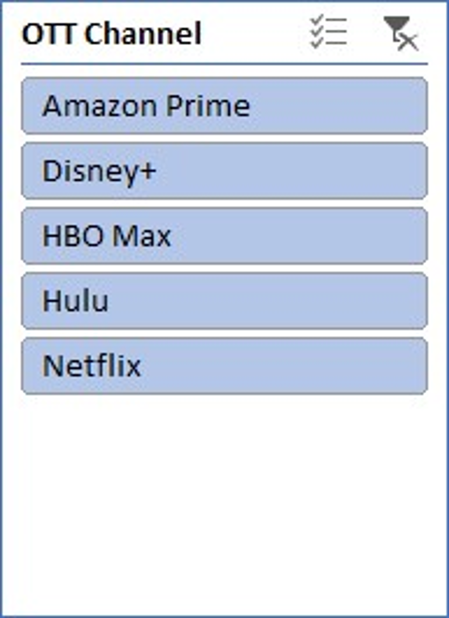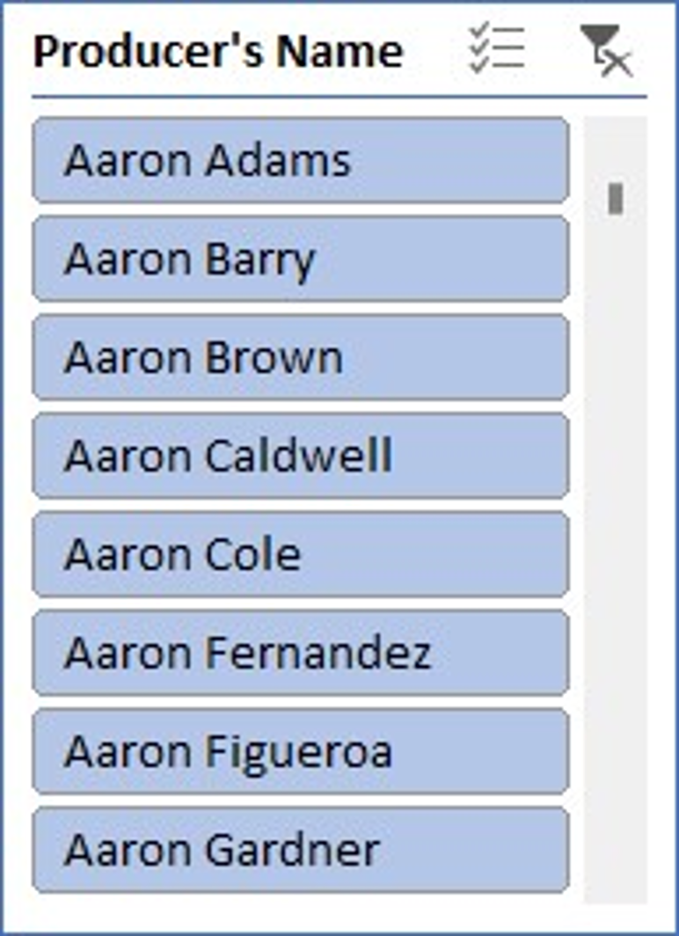

**Pie Charts**

1. Show the **percentage of total profit** by **OTT channel**, with slicers for **language** and **country**.

|  |  |
| --- | --- |
|  |  |
| **OTT Channel** | **Count of Profit ($M)** |
| Amazon Prime | 2384 |
| Disney+ | 2419 |
| HBO Max | 2345 |
| Hulu | 2466 |
| Netflix | 2386 |
| **Grand Total** | **12000** |
|  |  |



1. Display the **percentage of views** by **genre**, with slicers for **release year** and **OTT channel**.

|  |  |
| --- | --- |
|  |  |
| **OTT Channel** | **Count of Views (Million)** |
| Action | 1974 |
| Crime | 2027 |
| Drama | 1990 |
| Fantasy | 1980 |
| Sci-Fi | 2066 |
| Thriller | 1963 |
| **Grand Total** | **12000** |

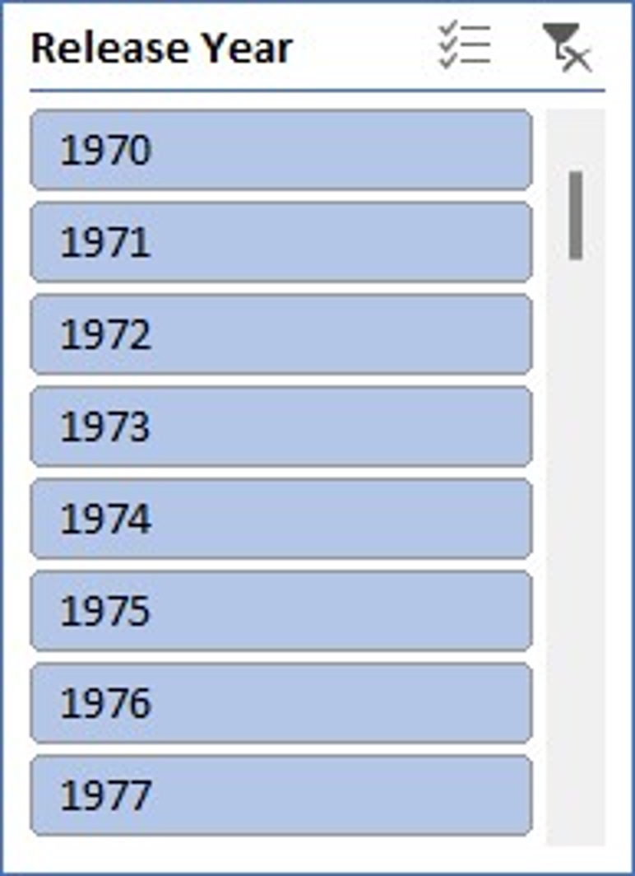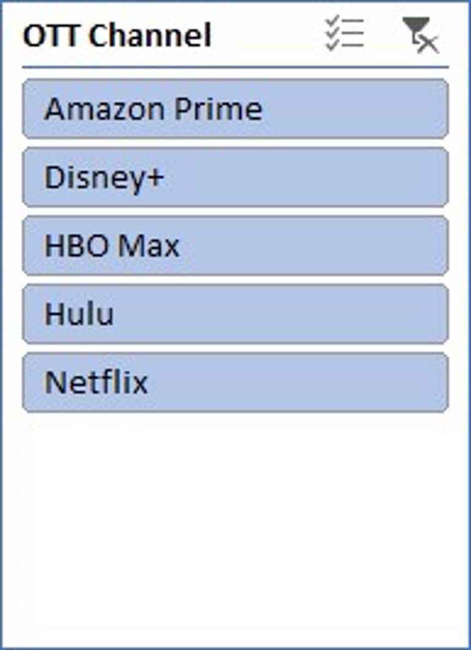

1. Show the **marketing expense distribution** by **social media platform**, using slicers for **release year** and **genre**.

|  |  |
| --- | --- |
|  |  |
| **Social Media** | **Count of Marketing Expense ($M)** |
| Facebook, Instagram | 2974 |
| Instagram, Twitter | 3101 |
| Twitter, Facebook | 3006 |
| YouTube, Instagram | 2919 |
| **Grand Total** | **12000** |
|  |  |

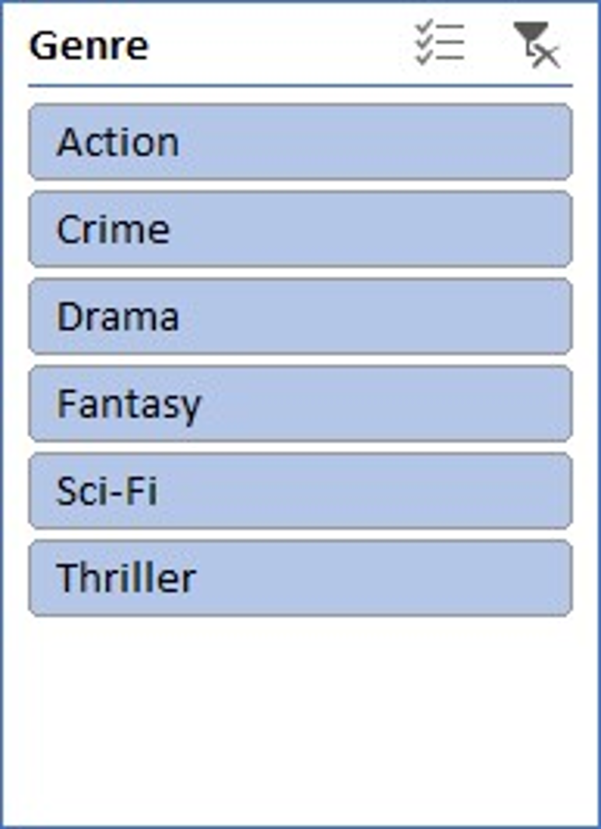

1. Display the **profit contribution** by **language**, with slicers for **country** and **OTT channel**.

|  |  |
| --- | --- |
|  |  |
| **Language** | **Count of Profit ($M)** |
| English | 4022 |
| Hindi | 4019 |
| Spanish | 3959 |
| **Grand Total** | **12000** |
|  |  |
|  |  |
|  |  |

1. Show the **percentage of sales** by **age group**, with slicers for **genre** and **release year**.

|  |  |
| --- | --- |
|  |  |
| **Age Group** | **Count of Sales (Numbers)** |
| 18-34 | 3955 |
| 18-45 | 4052 |
| 25-54 | 3993 |
| **Grand Total** | **12000** |
|  |  |

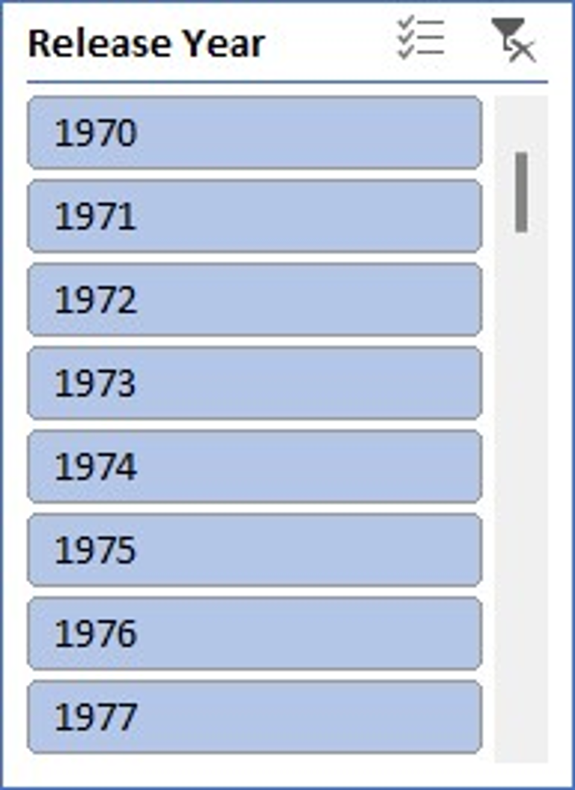

1. Compare the **viewership distribution** by **country**, using slicers for **language** and **genre**.

|  |  |
| --- | --- |
|  |  |
| **Age Group** | **Count of Views (Million)** |
| India | 2942 |
| Spain | 3047 |
| UK | 2974 |
| USA | 3037 |
| **Grand Total** | **12000** |



1. Show the **royalty percentage contribution** by **OTT channel**, with slicers for **producer** and **language**.

|  |  |
| --- | --- |
|  |  |
| **OTT Channel** | **Count of Royalty Percentage** |
| Amazon Prime | 2384 |
| Disney+ | 2419 |
| HBO Max | 2345 |
| Hulu | 2466 |
| Netflix | 2386 |
| **Grand Total** | **12000** |
|  |  |

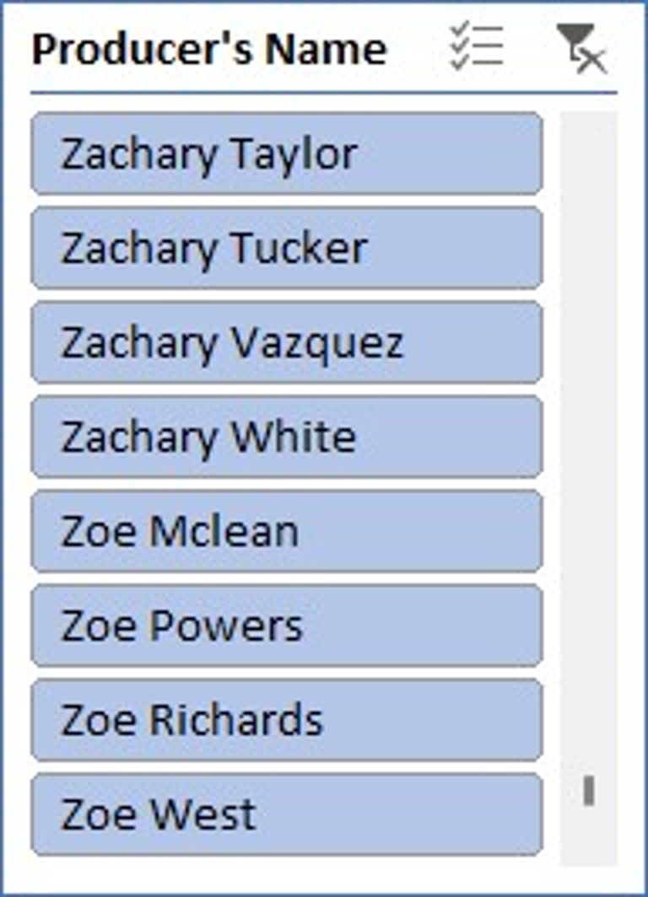

**AVERAGEIF Questions**

Find the **average profit** for all movies in the **Action** genre. : 272.704154

Calculate the **average views (millions)** for movies released in **Spain**. : 39.80767968

Determine the **average making charges** for movies with an **IMDb rating** above 8. : **89.78206452**

Find the **average marketing expense** for movies/shows with **sales numbers** greater than 40,000,000. : **40647112.38**

Compute the **average IMDb rating** for all movies on **Netflix**. : 8.499077955

**SUMIF Questions**

Calculate the **total profit** for all movies in the **Drama** genre. : 550058

Find the **total marketing expense** for movies released in **India**. : 101852

Compute the **total views (millions)** for movies with a **Rotten Tomatoes rating** of 90% or higher. : **244422**



Add up the **making charges** for movies/shows released after the year **2000**. : **468499**

2. Determine the **total sales numbers** for all movies with a **profit margin** greater than 20%. :

**COUNTIF Questions**

Count the number of movies in the **Thriller** genre. : 1963

Find the total number of movies produced in **English**. : 4022

1. Count the number of movies with a **profit margin** above 50%. : 9348

Determine how many movies were released on **Hulu**. : 2466

1. Count the number of movies with an **IMDb rating** greater than or equal to 9. : 3860